# DSM Transport Safety Requirements

To ensure safety during transport, reception and offloading, supplier hereby declares that:

* In case of supplying packaged goods:
* Supplied shipping units are palletized and stable, meaning packages are secured together and to the pallet following the instructions from the packaging supplier, or by banding, strapping or stretch/shrink wrap to ensure the unit does not deform or can slide from the pallet (according European Standard EN12195-1 or pre-agreed equivalent standard).

 

* Supplied load is adequately secured in accordance with “IMO (International Maritime Organization) CTU-code” for sea freight and “FMCSA (Federal Motor Carrier Safety Administration) North America Cargo Securement Standard” or “EC (European Commission) European best practice guidelines on cargo securing” for road transport.

Note: if local legislation is more strict than these requirements, local legislation will prevail.

For practical guidance to ensure load securing in accordance with specified standards, see:

<https://www.imo.org/en/OurWork/Safety/Pages/CTU-Code.aspx>

<https://www.fmcsa.dot.gov/regulations/cargo-securement/cargo-securement-rules>

<https://road-safety.transport.ec.europa.eu/eu-road-safety-policy/priorities/safe-vehicles/cargo-securing-and-abnormal-loads_en>

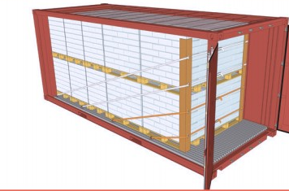 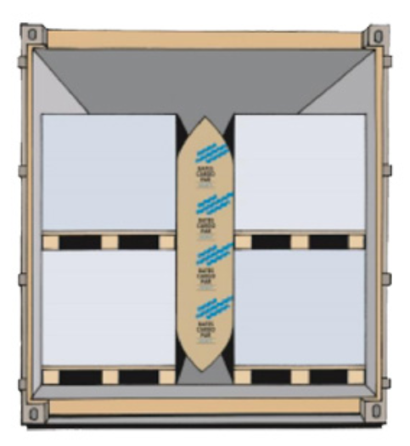

* Drivers entering a DSM site to deliver or pick up packaged goods or bulk goods:
* Are capable of effectively communicating the SHE relevant aspects with site personnel at the work place. The site defines a set of accepted languages. Driver’s language understanding is checked upon arrival for effective communication.
* Are qualified to drive and transport the concerned goods. Driver’s license and if applicable additional qualifications (i.e. Dangerous Goods) are checked as part of the preloading check.
* Comply with:
  + Site traffic and Personal Protection Equipment (PPE) rules
  + Relevant Life Saving Rules for drivers (drive safely, no drugs or alcohol, no smoking, observe working at heights requirements)
  + Wait for authorized site personnel before opening sides/doors of containers, trailers or opening hatches of tank trucks and tank containers
  + Follow site instructions to open and secure the truck for (un)loading

Company name of Supplier:

Name of Supplier Representative:

Title of Supplier Representative:

Date:

Signature: